Statistical Analysis of Nuclear Power Reactors

Dalton Shaver
College of Science and Mathematics, Kennesaw State University
STAT 3010: Computer Applications of Statistics
Professor Michael Frankel
November 24, 2021

Nuclear energy has become an important concern in recent months due to the pressure of discovering cleaner, efficient, and sustainable methods of producing energy. It is important to understand both the current capabilities and future potential of nuclear reactors if nuclear energy is to play a key part in solving the climate crisis. This analysis aims to understand the growth and development of nuclear reactors since their invention. The purpose is to examine the characteristics of nuclear power plants. This includes the geographical distribution of reactors, efficiency of energy production, and operational lifespan. The ability to understand the future growth and development of nuclear reactors is essential in order to maintain a key source of sustainable energy.
The dataset used in this analysis was obtained by the International Atomic Energy Agency. The specific data is found in the Power Reactor Information System (PRIS) database. The dataset includes technical and performance data on all reactors operating in the world. As shown in Table 1, it includes 754 observations and 12 variables, of which seven are quantitative and four are qualitative. The Reactor Name is the identifier variable in the dataset. This dataset includes key information in technical factors such as gross and net electrical power production, energy efficiency, and years of construction and operation. The variable Gross Electrical Capacity is the maximum amount of power that the nuclear reactor is designed to generate under optimal conditions, while Reference Unit Power is the amount of power the reactor can generate after deducting energy losses. Additionally, Table 1 shows that this technical data is measured in Megawatts (MW). Variables CSY (Construction Start Year), GCY (Grid Connection Year), Shutdown Date, and Age are all measured in years. Finally, EAF% (Energy Availability Factor) is the percentage of the nuclear reactor’s reference power that is not lost. This simply measures the efficiency of energy production, as a high EAF% represents low energy loss.
The dataset also includes four qualitative variables, consisting of Country, Status, Type, and Region. Country is the name of the country in which the nuclear reactor resides. Status is the operational status of the reactor. The four statuses in this dataset are Operational, Under Construction, Planned, and Permanently Shutdown. The variable Type is the official design of the nuclear reactor. Finally, Region is the designated geographical region in which the reactor’s country is a part of. Every observation in the analysis has a value for these qualitative variables, regardless of reactor status.
This dataset provides information that is necessary for governments, organizations, and corporations to analyze the distribution and efficiency of nuclear reactors on a global scale. The comprehensive PRIS database is continuously updated by IAEA Member States in order to provide the most recent and relevant data. The data is also released annually in the Nuclear Power Reactors in the World publication and is a dependable source used in international dialogue. Technical data is the most important factor in climate change debate, and this dataset is a source that allows nuclear energy to have a viable role in clean energy production.
Table 2 shows the descriptive statistics of each quantitative variable in the analysis. It shows that both Gross Electrical Capacity and Reference Unit Power have similar standard deviations of 413.32 MW and 407.54 MW. Another key result from the table includes the difference of mean and median values of GCY and CSY. The difference between means is 4.78 years, while the difference between medians is 8 years. When examining the distribution of both GCY and CSY, most nuclear reactors have a construction time between 5 and 8 years. Furthermore, the mean age of reactors is 30.18 years. This information grants a better insight into the cyclical process of reactors, from construction start to permanent shutdown.
An analysis focusing on measurements of central tendency, dispersion, and mode were conducted for each qualitative and quantitative variable in the dataset. The key results from Table 3 is that 5 countries (USA, China, Japan, Russia, and France) account for exactly 58.35% of all nuclear reactors. The United States is the largest contributor to this statistic, with a reactor count of 135. This includes permanently shutdown, active, under construction, and planned reactors. Additionally, 16 countries have 5 or less reactors, accounting for only 5.21% of all nuclear reactors in the dataset. According to Table 4, Western Europe is the leading region with 235 nuclear reactors. East Asia has the second most reactors, followed by North America. Africa, Latin America, and the Middle East together account for only 7.7% of nuclear reactors in the world. Table 5, for the variable Status, shows that out of the total 754 nuclear reactors in the dataset, 58.62% are currently operational. A further 25.46% are permanently shutdown. According to the IAEA, 52 reactors are currently under construction, while 68 reactors are officially planned for construction. Table 6 is a frequency table of reactor types. 752 nuclear reactors consist of 10 defined reactor types, while the remaining 2 are defined as ‘Other’. The majority (60.96%) of all nuclear reactors are Pressurized Light-Water Moderated and Cooled Reactors (PWR).
The electrical output of each nuclear reactor is measured by Gross Electrical Capacity and Reference Unit Power. The distribution of Gross Electrical Capacity is unimodal and left-skewed. Additionally, the distribution consists of no outliers. Therefore, the mean, 848.63 MW is the appropriate measurement of central tendency. The standard deviation is 413.32 MW, representing a wide dispersion among the data. According to Figures 1.1 and 1.2, there are very few nuclear reactors that have generated or currently produce 1500 MW or more of electrical power. Reference Unit Power is the Net Electrical Power Generation, the measure of electrical energy that a reactor continuously supplies, taking into account planned and unplanned energy losses. Similar to Gross Electrical Capacity, the distribution is unimodal and left-skewed shown in both Figures 2.1 and 2.2. The mean, 785.37 MW, is 63.26 MW lower than the mean of Gross Electrical Capacity. Additionally, the standard deviations of both Reference Unit Power (407.54 MW) and Gross Electrical Capacity (413.32 MW) are very similar values. As shown in Figure 3.1, the distribution of the Energy Availability Factor is also unimodal and skewed to the left. The mean, 77.06%, is slightly lower than the median, 80.25%. Figure 3.2 shows many outliers in the distribution, causing the median and Interquartile Range to be the appropriate measurements. Understandably, the maximum only reaches 94.10%, as it would be nearly impossible for a nuclear reactor to operate without suffering energy losses.
According to Figure 4.1, the distribution of Construction Start Year is unimodal and right-skewed. The mean (1979.96) and median (1975) represent a surge in the construction of nuclear power facilities. There was a small increase in constructions in 2010, which skews the central tendency. Figure 4.2 also shows outliers present from 2010 to 2021 representing a steady construction of nuclear reactors each year. The distribution of Grid Connection Year resembles that of Construction Start Year, as this is when the plant is first connected to the electrical grid, post-construction. As Figures 5.1 and 5.2 show, the distribution of Grid Connection Year is unimodal and right-skewed. Therefore, the median, 1983, and Interquartile Range, 16.00 years, are appropriate when analyzing the variable. The distribution of Shutdown Date is bimodal. The two modes include more than 40 nuclear reactor shutdowns in the 1990s, and more than 30 shutdowns in the past 5 years. Figure 6.1 shows an increase in shutdowns starting in 2000, correlating to the significant increase in nuclear reactor constructions in the 1980s. The distribution is also skewed to the left (seen in Figure 6.2), as the mean (1999.17) is lower than the median (2002). Assessing reactor age, both Figure 7.1 and Figure 7.2 show the distribution is left-skewed and unimodal. The mean age of nuclear reactors is 30.18 years, compared to a median of 34.00 years. The mean and standard deviation (13.55 years) are considered the appropriate measurement of central tendency and dispersion as there are no outliers present. The oldest nuclear reactor is 52 years old.
To better analyze Reference Unit Power, each nuclear reactor was placed in a category measuring the level of power generation. Low Capacity is defined as reactors with electrical power capacity less than 479 MW. Medium Capacity is power generation between 479 MW and 1066 MW. High Capacity is reactors between 1067 MW and 1277 MW. Finally, Very High Capacity is power plants generating greater than 1277 MW. According to Table 7, 26.29% of all nuclear reactors fall into either the High Capacity or Very High Capacity category for power generation. This is slightly higher than the 25.10% of reactors that are considered Low Capacity. Therefore, reactors generating more than 1067 MW are more common than those generating less than 479 MW. The most common electrical capacity category is Medium Capacity, accounting for 48.54% of all reactors.
To better understand the relationship among multiple variables, I conducted three multivariate analyses consisting of six variables. The first multivariate analysis is a contingency table (Table 8) and stacked bar chart (Figure 9.1) of Region by Status. My research hypothesis for this analysis is that America – North will have more Operational, Under Construction, and Planned nuclear reactors than other regions. The analysis proves this incorrect for all types of reactors. The explanatory variable in this statistical analysis is Region, while the response variable is Status. The second multivariate analysis determines the relationship between Type, as the explanatory variable, and EAF% as the response variable. The research hypothesis was that the reactor type PWR has the highest Energy Availability Factor Percentage as it has the highest frequency among reactor types. Table 8, Table 9, and Figure 10.1 supports the hypothesis by displaying PWR as the highest mean and median. It’s quartile range is also relatively small, representing a narrower dispersion. The final multivariate analysis measures the relationship between Grid Connection Year (Explanatory Variable) and Gross Electrical Capacity (Response Variable). My research hypothesis was that Gross Electrical Capacity has a positive correlation with GCY. Further examination of Figure 11.1 shows that this is true. There is a sharp increase in Gross Electrical Capacity between the years of 1960 and 1990. Moreover, reactors built after 1990 generally maintain a high capacity.
The first multivariate analysis, Region by Status, explores the geographical distribution of nuclear reactors. According to Table 8, East Asia has a strong desire to boost nuclear power in the future. 36.54% of reactors under construction and 57.35% of planned reactors are in East Asia, totaling 58 future reactors. When comparing North America’s two reactors under construction and none officially planned in Table 8, four of the seven global regions have more future reactors in production. The other component of my research hypothesis also failed because Western Europe has 10 more operational nuclear reactors than North America has. These results are important because they directly show both future regional development and past experience in nuclear power technology since its creation. Further research into individual countries would benefit the general understanding of nuclear power development in the world.
Secondly, the analysis of Type and EAF% examines the efficiency of all nuclear reactor designs. Energy Availability Factors are only applicable for currently operational reactors; therefore the dataset has been reduced to perform this multivariate analysis. According to Table 9, reactor type PWR has a mean of 79.33% and 302 observations. 63 operational reactors are a BWR design with a mean of 71.83%, and 48 reactors are a PHWR design with a mean of 74.62%. Figure 10.1 shows that the three most frequent reactor types are also the most efficient. Based on a random sample of 80 observations, we can be 95% confident the average energy availability factor for operational reactors of type PWR is between 71.03% and 80.32%. This is shown by Table 10. While four other designs have a higher upper confidence level than PWR, the number of observations for each one is significantly lower than PWR. Table 10 also shows design FBR has a very large confidence interval, consisting of efficiency values that physically cannot be achieved. This is caused by an minuscule observation count of two, and the original data being skewed to the left. These analysis results are crucial in planning new reactor constructions, and promoting further research into building more efficient designs. Future research should involve additional variables associated to operational nuclear reactors in order to reach the most optimal energy-producing conditions.
The third multivariate analysis investigated the relationship between Gross Electrical Capacity and Grid Connection Year. Figure 11.1 shows a rapid increase from 1960 to 1990. Gross Electrical Capacity plateaued at roughly 1500 MW in the late 1990s until 2018. Two new reactors, both with a gross capacity of 1750 MW, were designated operational in 2018 and 2019. Most reactors connected to the electrical grid after 2000 remained close to 1000 MW in gross capacity. This is likely the result of balancing upkeep cost with efficient energy production. Additional analyses with variables such as Region or Country would provide a deeper understanding of the change of Gross Electrical Capacity over time.

Appendix 1: Tables and Figures

Table 1: List of Variables and Attributes

Name | Label | General Type | Specific Type | Measurement Units
Country | Name of country in which nuclear reactor resides | Categorical | Nominal | N/A
Status | Operational status of nuclear reactor (Permanently Shutdown, Operational, Under Construction, Planned) | Categorical | Nominal | N/A
Reactor Name | Official name |  | Identifier | N/A
Type | Official design of nuclear reactor | Categorical | Nominal | N/A
Gross Electrical Capacity | Gross Electrical Power Generation | Quantitative | Continuous | Megawatts (MW)
Reference Unit Power | Net Electrical Power Generation | Quantitative | Continuous | Megawatts (MW)
CSY | Construction Start Year | Quantitative | Discrete | Years
GCY | Grid Connection Year | Quantitative | Discrete | Years
EAF % | Energy Availability Factor | Quantitative | Continuous | N/A
Shutdown Date | Year in which reactor was permanently shutdown | Quantitative | Discrete | Years
Age | Reactor Age | Quantitative | Discrete | Years
Region | Name of region in which host country is located | Categorical | Nominal | N/A
Number of Observations = 754

Table 2: Descriptive Statistics for Nuclear Power Dataset

Variable | Label | Minimum | Lower Quartile | Median | Mean | Upper Quartile | Maximum | Std Dev | Quartile Range
Gross Electrical Capacity  Reference Unit Power  CSY  GCY  EAF %  Shutdown Date  Age | Gross Electrical Power Generation (MW)  Net Electrical Power Generation (MW)  Construction Start Year  Grid Connection Year  Energy Availability Factor  Shutdown Date  Age | 3.00  0.00  1951.00  1954.00  0.00  1963.00  0.00 | 540.00  479.00  1969.00  1974.00  74.00  1989.00  21.00 | 955.00  910.00  1975.00  1983.00  80.25  2002.00  34.00 | 848.63  785.37  1979.96  1984.74  77.06  1999.17  30.18 | 1180.00  1067.00  1986.00  1990.00  86.50  2013.00  40.00 | 1750.00  1660.00  2021.00  2026.00  94.10  2020.00  52.00 | 413.32  407.54  16.55  15.29  15.27  15.34  13.55 | 640.00  588.00  17.00  16.00  12.50  24.00  19.00

Table 3: Frequency Table for Country
Country | Frequency | Percent | Cumulative  Frequency | Cumulative  Percent
ARGENTINA | 4 | 0.53 | 4 | 0.53
ARMENIA | 2 | 0.27 | 6 | 0.80
BANGLADESH | 2 | 0.27 | 8 | 1.06
BELARUS | 2 | 0.27 | 10 | 1.33
BELGIUM | 8 | 1.06 | 18 | 2.39
BRAZIL | 3 | 0.40 | 21 | 2.79
BULGARIA | 6 | 0.80 | 27 | 3.58
CANADA | 25 | 3.32 | 52 | 6.90
CHINA | 92 | 12.20 | 144 | 19.10
CZECH REP. | 6 | 0.80 | 150 | 19.89
FINLAND | 6 | 0.80 | 156 | 20.69
FRANCE | 71 | 9.42 | 227 | 30.11
GERMANY | 36 | 4.77 | 263 | 34.88
HUNGARY | 6 | 0.80 | 269 | 35.68
INDIA | 31 | 4.11 | 300 | 39.79
IRAN,ISL.REP | 4 | 0.53 | 304 | 40.32
ITALY | 4 | 0.53 | 308 | 40.85
JAPAN | 72 | 9.55 | 380 | 50.40
KAZAKHSTAN | 1 | 0.13 | 381 | 50.53
KOREA,REP.OF | 30 | 3.98 | 411 | 54.51
LITHUANIA | 2 | 0.27 | 413 | 54.77
MEXICO | 2 | 0.27 | 415 | 55.04
NETHERLANDS | 2 | 0.27 | 417 | 55.31
PAKISTAN | 7 | 0.93 | 424 | 56.23
ROMANIA | 2 | 0.27 | 426 | 56.50
RUSSIA | 70 | 9.28 | 496 | 65.78
SLOVAKIA | 9 | 1.19 | 505 | 66.98
SLOVENIA | 1 | 0.13 | 506 | 67.11
SOUTH AFRICA | 2 | 0.27 | 508 | 67.37
SPAIN | 10 | 1.33 | 518 | 68.70
SWEDEN | 13 | 1.72 | 531 | 70.42
SWITZERLAND | 6 | 0.80 | 537 | 71.22
TAIWAN,CHINA | 6 | 0.80 | 543 | 72.02
TURKEY | 4 | 0.53 | 547 | 72.55
UAE | 4 | 0.53 | 551 | 73.08
UK | 47 | 6.23 | 598 | 79.31
UKRAINE | 21 | 2.79 | 619 | 82.10
USA | 135 | 17.90 | 754 | 100.00

Table 4: Frequency Table for Region

Region | Frequency | Percent | Cumulative  Frequency | Cumulative  Percent
Africa | 2 | 0.27 | 2 | 0.27
America - Latin | 7 | 0.93 | 9 | 1.19
America - Northern | 162 | 21.49 | 171 | 22.68
Asia - Far East | 200 | 26.53 | 371 | 49.20
Asia - Middle East | 49 | 6.50 | 420 | 55.70
Europe - Central a | 99 | 13.13 | 519 | 68.83
Europe - Western | 235 | 31.17 | 754 | 100.00

Table 5: Frequency Table for Status

Status
Status | Frequency | Percent | Cumulative  Frequency | Cumulative  Percent
Operational | 442 | 58.62 | 442 | 58.62
Permanently Shutdown | 192 | 25.46 | 634 | 84.08
Planned | 68 | 9.02 | 702 | 93.10
Under Construction | 52 | 6.90 | 754 | 100.00

Table 6: Frequency Table for Type

Reactor Type
Type | Frequency | Percent | Cumulative  Frequency | Cumulative  Percent
BWR | 123 | 16.33 | 123 | 16.33
FBR | 18 | 2.39 | 141 | 18.73
GCR | 52 | 6.91 | 193 | 25.63
HTGR | 5 | 0.66 | 198 | 26.29
HWGCR | 4 | 0.53 | 202 | 26.83
HWLWR | 2 | 0.27 | 204 | 27.09
LWGR | 24 | 3.19 | 228 | 30.28
PHWR | 63 | 8.37 | 291 | 38.65
PWR | 459 | 60.96 | 750 | 99.60
SGHWR | 1 | 0.13 | 751 | 99.73
X | 2 | 0.27 | 753 | 100.00
Frequency Missing = 1

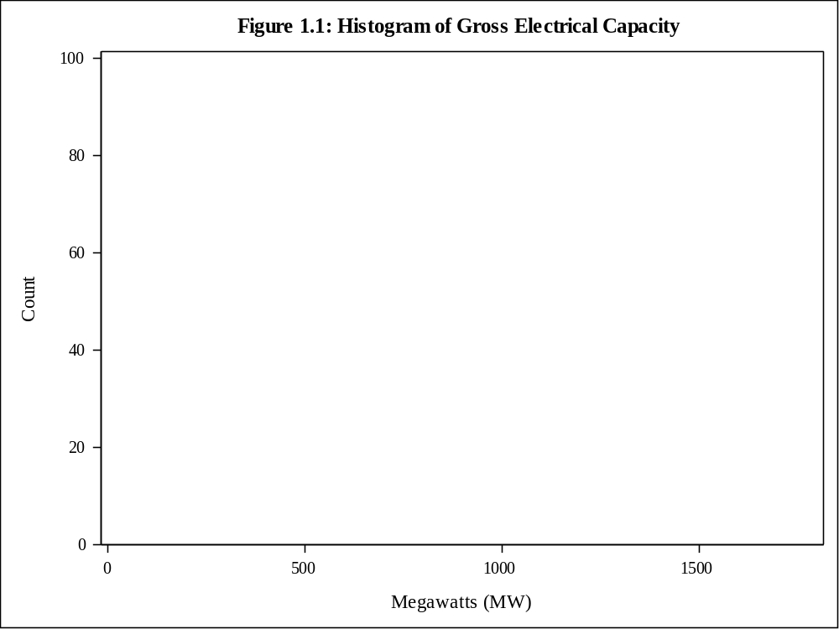

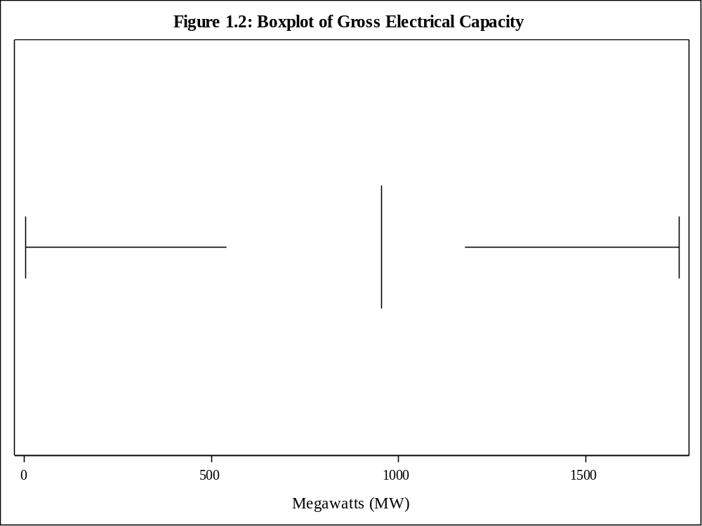

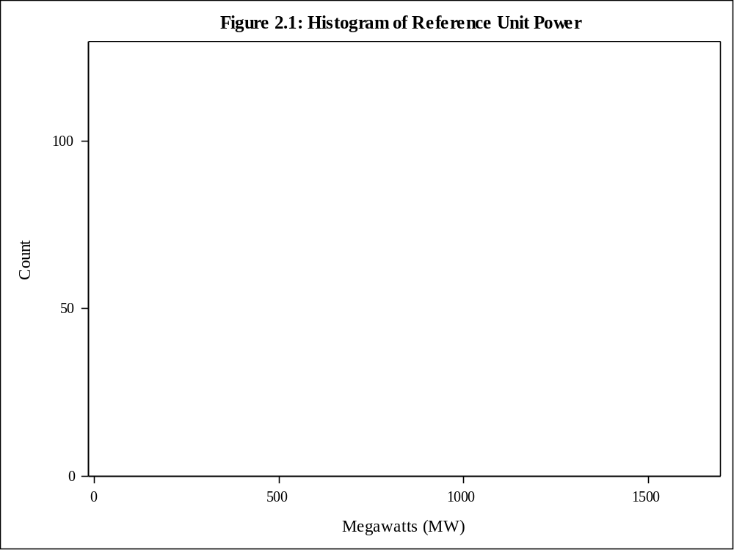

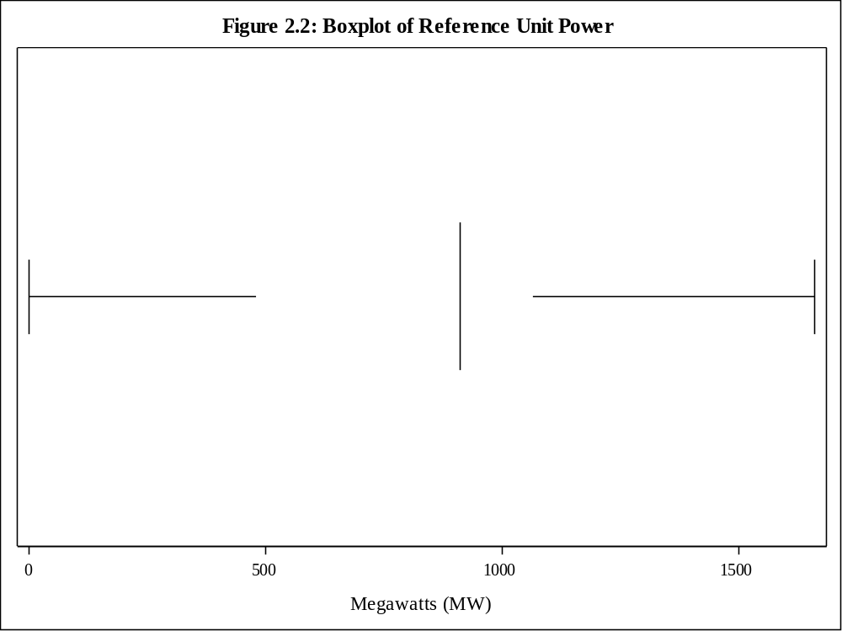

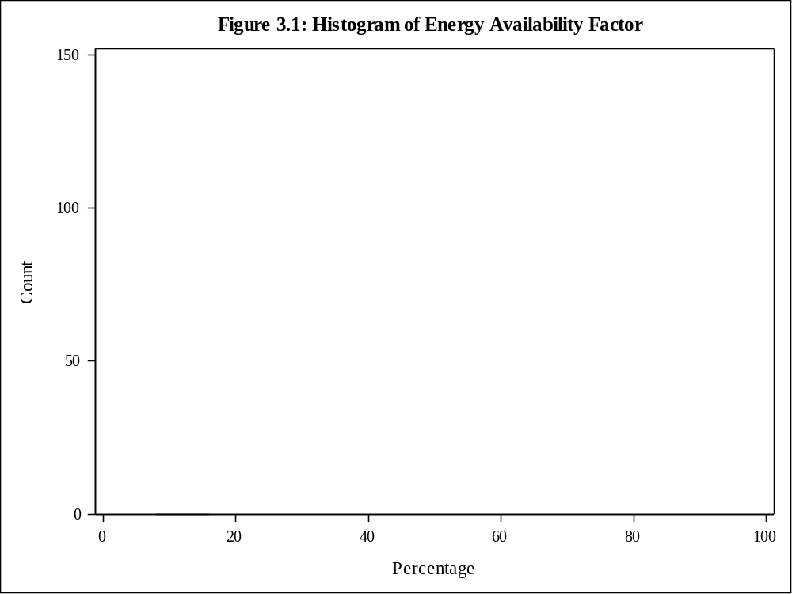

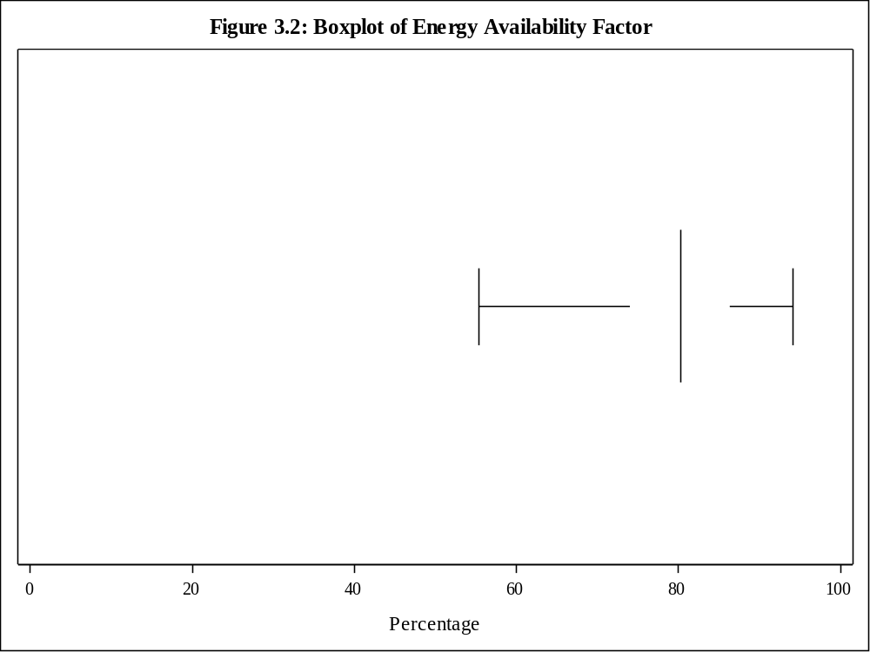

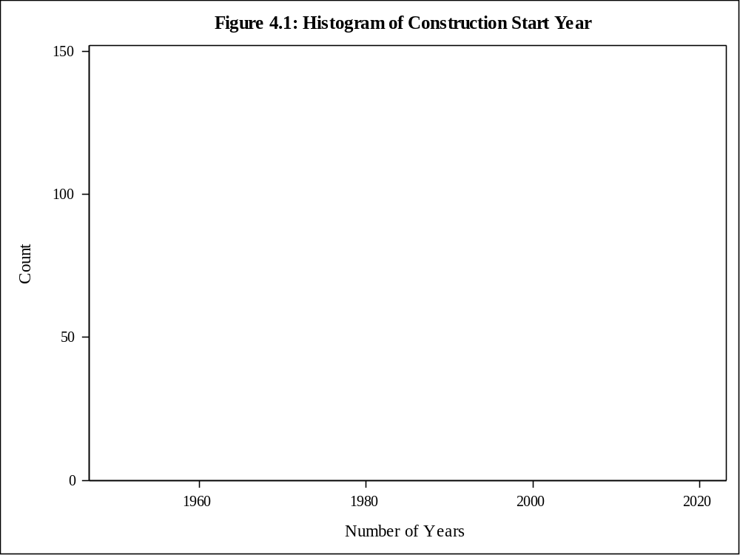

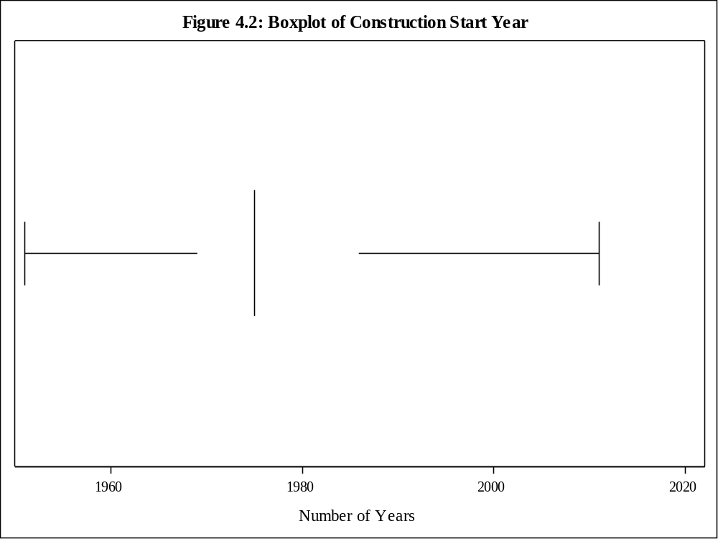

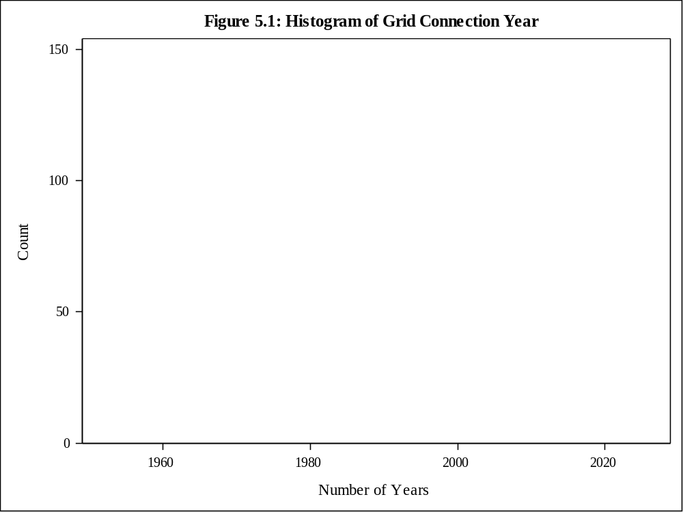

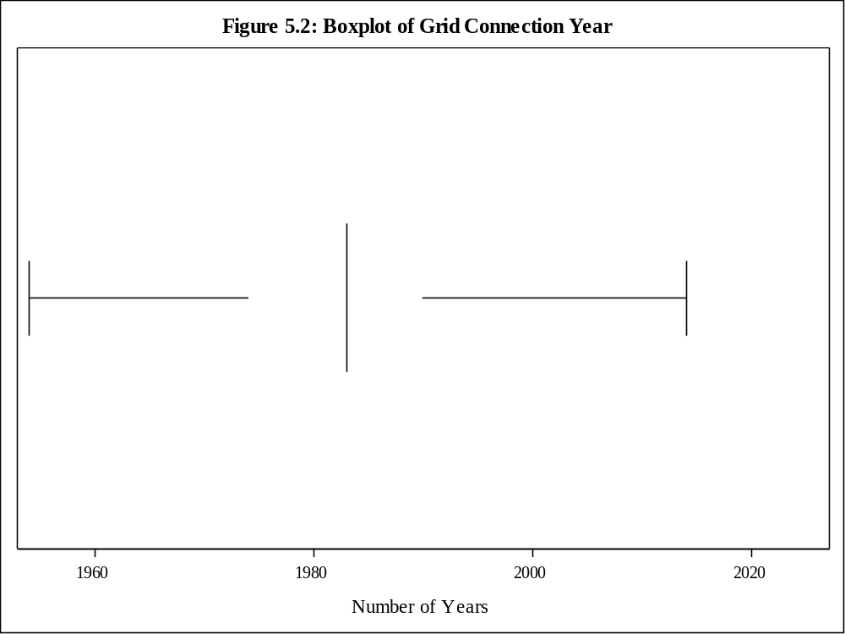

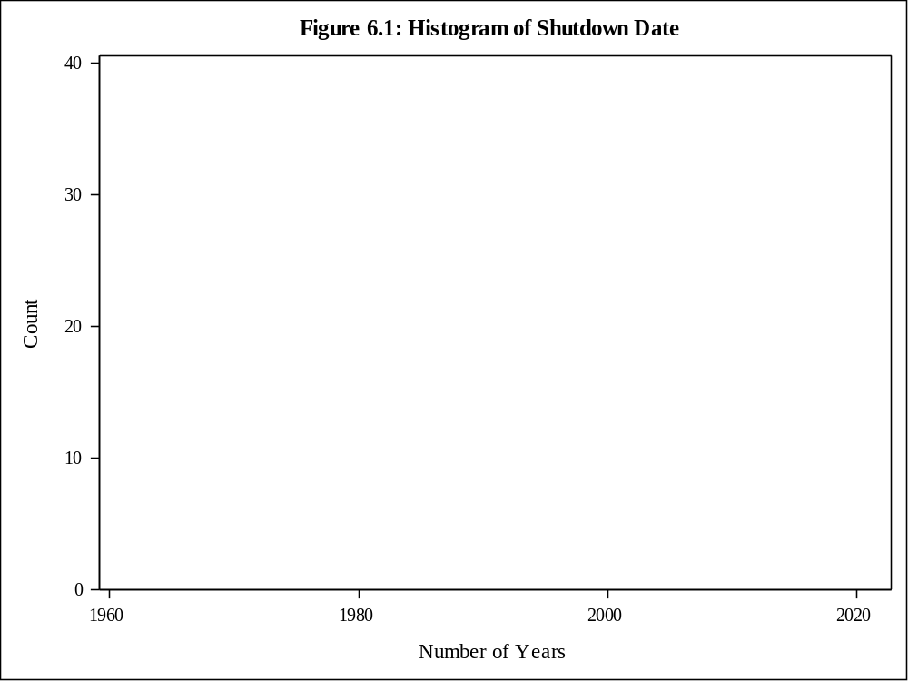

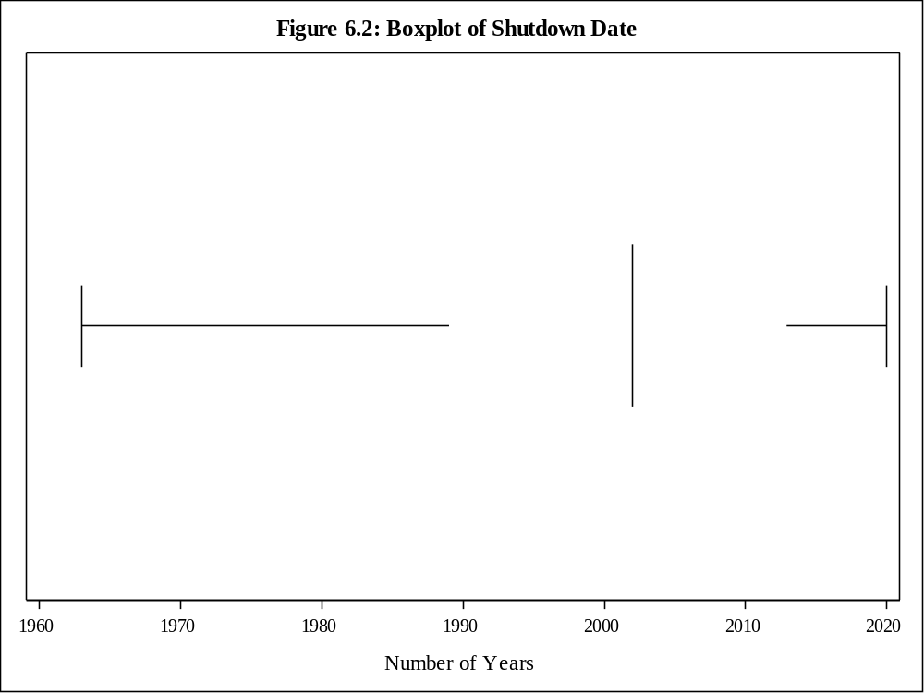

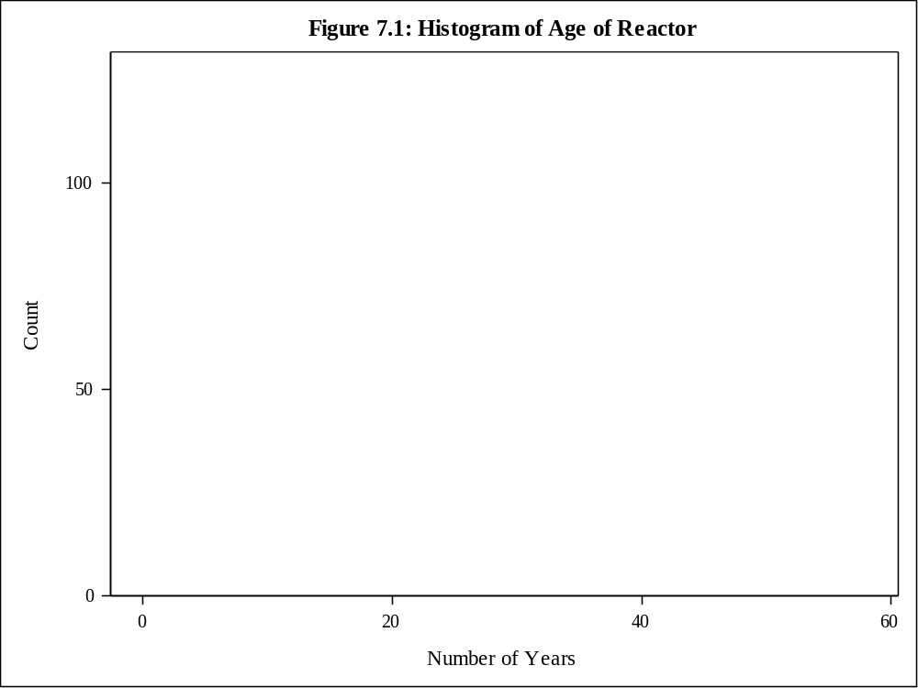

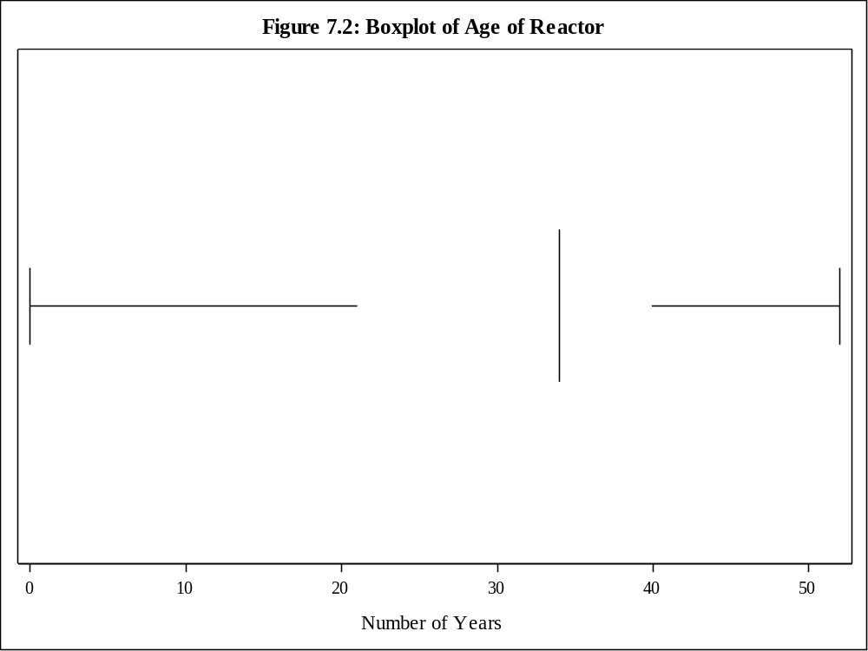

Table 7: Frequency Table for Power Generation

Power Generation | Frequency | Percent | Cumulative  Frequency | Cumulative  Percent
Low Capacity | 189 | 25.07 | 189 | 25.07
Medium Capacity | 366 | 48.54 | 555 | 73.61
High Capacity | 123 | 16.31 | 678 | 89.92
Very High Capacity | 76 | 10.08 | 754 | 100.00

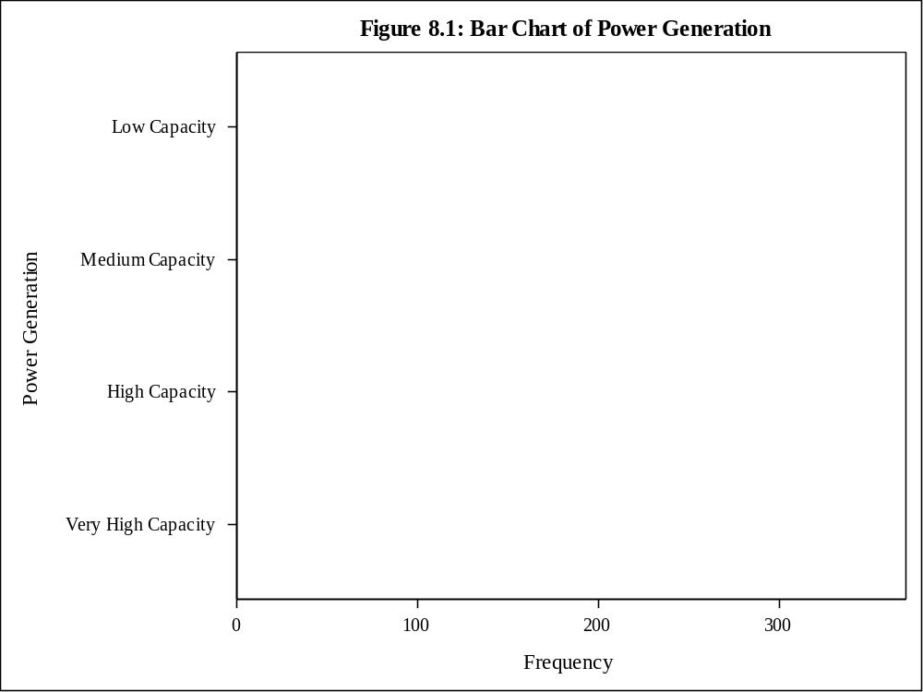

Table 8: Contingency Table for Region by Status
Region | Status(Status)
Frequency  Percent  Row Pct  Col Pct | Operational | Permanently Shutdown | Planned | Under Construction | Total
Africa | 2  0.27  100.00  0.45 | 0  0.00  0.00  0.00 | 0  0.00  0.00  0.00 | 0  0.00  0.00  0.00 | 2  0.27
America - Latin | 5  0.66  71.43  1.13 | 0  0.00  0.00  0.00 | 0  0.00  0.00  0.00 | 2  0.27  28.57  3.85 | 7  0.93
America - Northern | 115  15.25  70.99  26.02 | 45  5.97  27.78  23.44 | 0  0.00  0.00  0.00 | 2  0.27  1.23  3.85 | 162  21.49
Asia - Far East | 111  14.72  55.50  25.11 | 31  4.11  15.50  16.15 | 39  5.17  19.50  57.35 | 19  2.52  9.50  36.54 | 200  26.53
Asia - Middle East | 29  3.85  59.18  6.56 | 1  0.13  2.04  0.52 | 4  0.53  8.16  5.88 | 15  1.99  30.61  28.85 | 49  6.50
Europe - Central a | 55  7.29  55.56  12.44 | 14  1.86  14.14  7.29 | 22  2.92  22.22  32.35 | 8  1.06  8.08  15.38 | 99  13.13
Europe - Western | 125  16.58  53.19  28.28 | 101  13.40  42.98  52.60 | 3  0.40  1.28  4.41 | 6  0.80  2.55  11.54 | 235  31.17
Total | 442  58.62 | 192  25.46 | 68  9.02 | 52  6.90 | 754  100.00

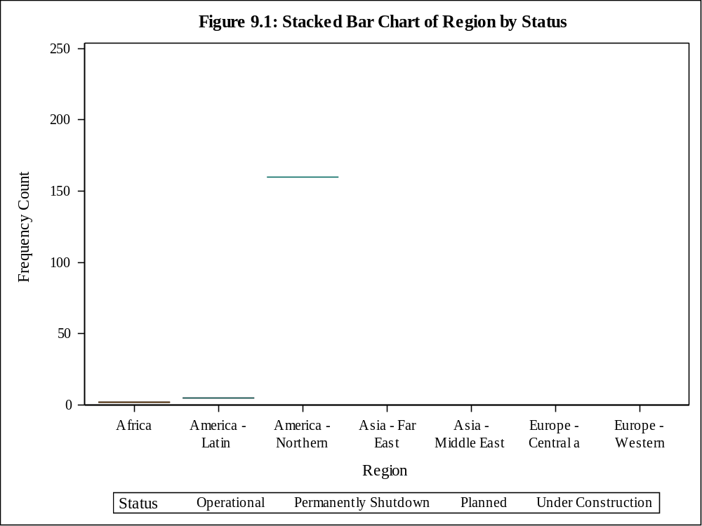

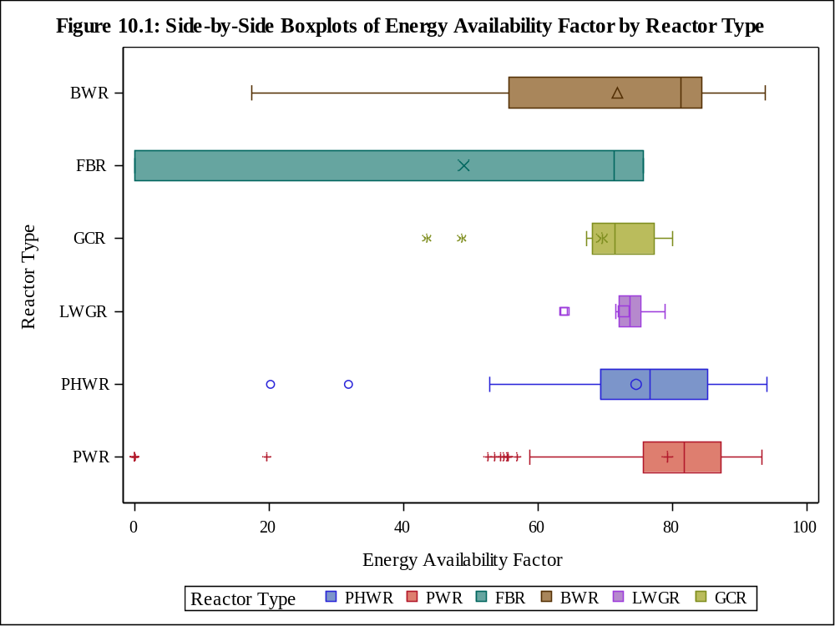

Table 9: Stratified Analysis of EAF% by Type
Reactor Type | N Obs | Minimum | Lower Quartile | Median | Mean | Upper Quartile | Maximum | Std Dev | Quartile Range
BWR | 63 | 17.40 | 55.70 | 81.30 | 71.83 | 84.40 | 93.80 | 20.01 | 28.70
FBR | 3 | 0.00 | 0.00 | 71.30 | 49.00 | 75.70 | 75.70 | 42.49 | 75.70
GCR | 14 | 43.50 | 68.10 | 71.45 | 69.57 | 77.30 | 80.10 | 10.77 | 9.20
LWGR | 12 | 63.80 | 72.15 | 73.65 | 72.78 | 75.30 | 78.90 | 4.62 | 3.15
PHWR | 48 | 20.20 | 69.30 | 76.70 | 74.62 | 85.30 | 94.10 | 14.40 | 16.00
PWR | 302 | 0.00 | 75.70 | 81.80 | 79.33 | 87.30 | 93.40 | 13.63 | 11.60

Table 10: 95% Confidence Interval for Type Sample
Reactor Type | N Obs | Mean | Lower 95%  CL for Mean | Upper 95%  CL for Mean
BWR | 13 | 67.64 | 52.71 | 82.57
FBR | 2 | 35.65 | -417.33 | 488.63
GCR | 4 | 66.35 | 46.37 | 86.33
LWGR | 2 | 73.05 | 68.60 | 77.50
PHWR | 9 | 80.69 | 73.07 | 88.30
PWR | 50 | 75.67 | 71.03 | 80.32

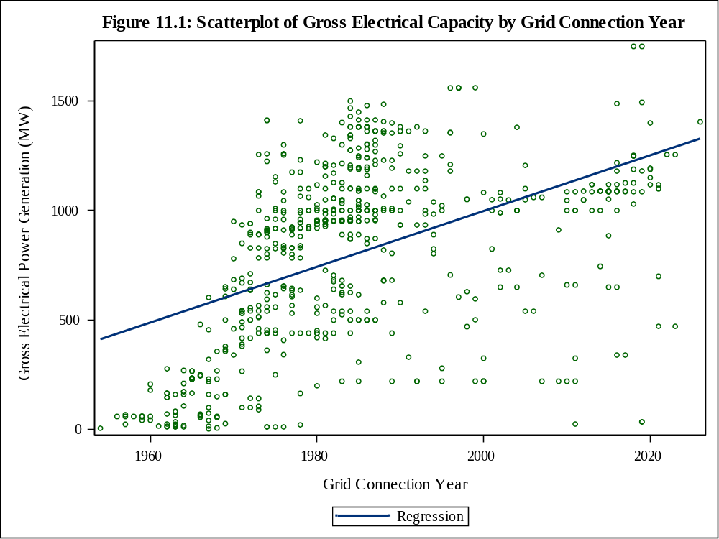

Appendix 2: SAS Code

*** Creating Library;
libname NPP '/home/u59781300/STAT 3010 NPP';

proc format;
value Generation 1 = "Low Capacity"
2 = "Medium Capacity"
3 = "High Capacity"
4 = "Very High Capacity";

********************************** Dataset Import & Setup;

proc import datafile='/home/u59781300/STAT 3010 NPP/NPP Dataset Import.xlsx'
dbms=xlsx
out=work.dataframe replace;
getnames=yes;

data NPP.dataframe;
set work.dataframe;
rename 'Construction Start'n=CSY 'Grid Connection'n=GCY
'Reactor Type'n=Type 'Gross Electrical Capacity [MW]'n='Gross Electrical Capacity'n
'Total Net Capacity [MW]'n='Reference Unit Power'n;
drop model operator 'nsss supplier'n 'Thermal Capacity [MW]'n 'Commercial Operation'n;
run;

*** Assigning Labels;
data NPP.dataframe;
set NPP.dataframe;
label CSY="Construction Start Year" GCY="Grid Connection Year" Type="Reactor Type"
'EAF %'n="Energy Availability Factor"
'Gross Electrical Capacity'n="Gross Electrical Power Generation (MW)"
'Reference Unit Power'n="Net Electrical Power Generation (MW)";
run;

*** Assigning Countries to Regions;
data NPP.dataframe;
set NPP.dataframe;
if Country='USA' or Country='CANADA' or Country='MEXICO'
then Region='America - Northern';
if Country='ARGENTINA' or Country='BRAZIL'
then Region='America - Latin';
if Country='CHINA' or Country='JAPAN' or Country='KOREA,REP.OF' or
Country='TAIWAN,CHINA'
then Region='Asia - Far East';
if Country='BANGLADESH' or Country='INDIA' or Country='IRAN,ISL.REP' or
Country='KAZAKHSTAN' or Country='PAKISTAN' or Country='UAE'
then Region='Asia - Middle East and South';
if Country='BELGIUM' or Country='BULGARIA' or Country='CZECH REP.' or
Country='FINLAND' or Country='FRANCE' or Country='GERMANY' or
Country='HUNGARY' or Country='ITALY' or Country='LITHUANIA' or
Country='NETHERLANDS' or Country='ROMANIA' or Country='SLOVAKIA' or
Country='SLOVENIA' or Country='SPAIN' or Country='SWEDEN' or
Country='SWITZERLAND' or Country='UK'
then Region='Europe - Western';
if Country='ARMENIA' or Country='BELARUS' or Country='TURKEY' or
Country='RUSSIA' or Country='UKRAINE'
then Region='Europe - Central and Eastern';
if Country='SOUTH AFRICA'
then Region='Africa';
run;

****************************** 5) Descriptive Statistics;
*Variable Information;
proc contents data=NPP.dataframe;

*Descriptive Statistics for Quantitative Variables;
proc means data=NPP.dataframe
min q1 median mean q3 max std qrange maxdec=2;

*Frequency Tables for Categorical Variables;
proc freq data=NPP.dataframe;
tables country region status type;

************************** Histograms and Boxplots for Quantitative Variables;
*** Macro creation;
%macro desc_stat(var=, name=, col=, num1=, num2=, lab=);
proc sgplot data=NPP.dataframe;
histogram &var/ scale=count fillattrs=(color=&col) dataskin=crisp;
title "Figure &num1: Histogram of &name";
xaxis label="&lab";

proc sgplot data=NPP.dataframe;
hbox &var/ fillattrs=(color=&col) lineattrs=(color='black') dataskin=crisp;
title "Figure &num2: Boxplot of &name";
xaxis label="&lab";
%mend;

*** Macro input;
%desc_stat(var="Gross Electrical Capacity"n, name=Gross Electrical Capacity, col=mogy,
num1=1.1, num2=1.2, lab=Megawatts (MW));
%desc_stat(var="Reference Unit Power"n, name=Reference Unit Power, col=vlibg,
num1=2.1, num2=2.2, lab=Megawatts (MW));
%desc_stat(var="EAF %"n, name=Energy Availability Factor, col=librgr,
num1=3.1, num2=3.2, lab=Percentage);
%desc_stat(var=CSY, name=Construction Start Year, col=stpk,
num1=4.1, num2=4.2, lab=Number of Years);
%desc_stat(var=GCY, name=Grid Connection Year, col=lirp,
num1=5.1, num2=5.2, lab=Number of Years);
%desc_stat(var="Shutdown Date"n, name=Shutdown Date, col=bigb,
num1=6.1, num2=6.2, lab=Number of Years);
%desc_stat(var=age, name=Age of Reactor, col=bilg, num1=7.1,
num2=7.2, lab=Number of Years);

************************* 6) Creation of Categorical Variable;

***Examined percentiles of variable;
proc univariate data=NPP.dataframe;
var 'Reference Unit Power'n;

***Creation of Categorical Variable from Quantitative Variable;
data NPP.dataframe;
set NPP.dataframe;
if 'Reference Unit Power'n < 479 then 'Power Generation'n = 1;
if 479 <= 'Reference Unit Power'n < 1067 then 'Power Generation'n = 2;
if 1067 <= 'Reference Unit Power'n < 1277 then 'Power Generation'n = 3;
if 'Reference Unit Power'n >= 1277 then 'Power Generation'n = 4;

data NPP.dataframe;
set NPP.dataframe;
format 'Power Generation'n Generation.;

proc freq data=NPP.dataframe;
tables 'Power Generation'n;

proc sgplot data=NPP.dataframe;
hbar 'Power Generation'n/ fillattrs=(color='lioy') dataskin=crisp;
title Figure 8.1: Bar Chart of Power Generation;

******************************* 7) Multivariate Analyses;

****Analysis 1: Region & Status;
*Contingency Table;
proc freq data=NPP.dataframe;
tables region*status;
ods output CrossTabFreqs=ConTable;

*100% Stacked Bar Chart;
proc sgplot data=ConTable;
vbar region / group=status response=frequency dataskin=crisp;
title Figure 9.1: Stacked Bar Chart of Region by Status;

****Analysis 2: Type & EAF %;
*Creation of Operation dataframe;
data NPP.operational_df;
set NPP.dataframe;
where Status='Operational';

*Stratified Analysis;
proc means data=NPP.operational_df
min q1 median mean q3 max std qrange maxdec=2;
var 'EAF %'n;
class type;
title ;

*Side-by-side boxplots;
proc sgplot data=NPP.operational_df;
hbox 'EAF %'n / category=type group=type;
title Figure 10.1: Side-by-Side Boxplots of Energy Availability Factor by Reactor Type;

**Sampled Stratified Confidence Intervals;
*Sample using SQL;
proc sql outobs=80;
CREATE TABLE NPP.sample_df AS
SELECT *
FROM NPP.operational_df
ORDER BY ranuni(25578);
quit;

*Stratified Confidence Intervals;
proc means data=NPP.sample_df mean lclm uclm alpha=0.05 maxdec=2;
var 'EAF %'n;
class type;
title ;

****Analysis 3: GCY & Gross Electrical Capacity;
*Scatterplot;
proc sgplot data=NPP.dataframe;
reg x = GCY y = 'Gross Electrical Capacity'n/ markerattrs=(symbol=circle size=5 color='darkgreen');
title Figure 11.1: Scatterplot of Gross Electrical Capacity by Grid Connection Year;

